Welcome to Providence Presbyterian Church!

Pastor
David Hina (858-395-3051)

Elders
Roddy Alt (828-361-9662) Wil Meiners (828-837-0240)
Terry Frederick (828-321-1488)

Trustees
Roddy Alt
Jackie Mueller
Steve Yount

Foreign Missionaries
Sandra Hart Manila, Philippines MTW
John & Elizabeth Sexton Arden, NC MTW
Scott & Ruth Hill Cherokee, NC MTW

Domestic Missions
Pregnancy and Parenting Center Murphy & Andrews, NC
PCA Administrative Committee Lawrenceville, GA
Committee on Discipleship Ministries Lawrenceville, GA
Covenant College Lookout Mountain, GA
Covenant Seminary St. Louis, MO
Mission to North America (MNA) Lawrenceville, GA
Mission to the World (MTW) Lawrenceville, GA
Ridge Haven Conference Center Brevard, NC
Western Carolina Presbytery Western North Carolina
Reformed University Fellowship Western Carolina Univ.

Providence Presbyterian Church (828) 837-9412
2252 Harshaw Road, Murphy, NC 28906
providencepcamurphy.org ◊ providencemurphy@gmail.com

Providence
Presbyterian Church
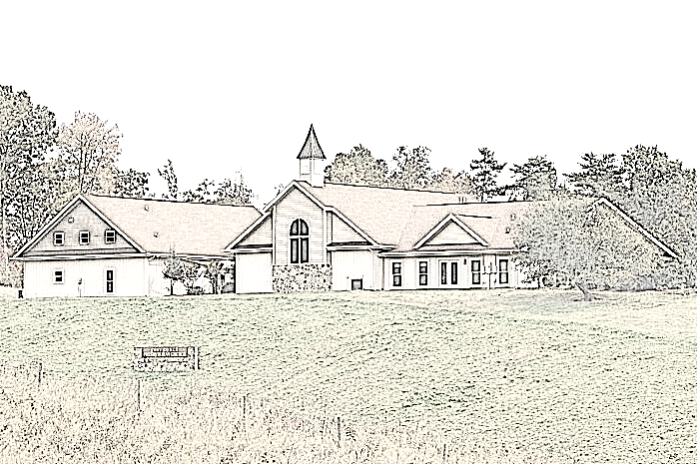

a congregation of The Presbyterian Church in America

The Celebration of Worship

August 5th, 2018—11:00 a.m.

Welcome and Announcements

Prelude
*Please stand if you are able.

God Calls Us to Worship

*Call to Worship Psalm 96:1-6
Leader: Oh sing to the LORD a new song;
sing to the LORD, all the earth!
People: Sing to the LORD, bless his name;
tell of his salvation from day to day.
Leader: Declare his glory among the nations,
his marvelous works among all the peoples!
People: For great is the LORD, and greatly to be praised;
he is to be feared above all gods.
Leader: For all the gods of the peoples are worthless idols,
but the LORD made the heavens.
People: Splendor and majesty are before him;
strength and beauty are in his sanctuary.
*Hymn of Praise #32
Great is Thy Faithfulness
*Invocation

Sermon Notes

Speak, O Lord, and renew our minds;
Help us grasp the heights of Your plans for us—
Truths unchanged from the dawn of time
That will echo down through eternity.
And by grace we'll stand on Your promises,
And by faith we'll walk as You walk with us.
Speak, O Lord, till Your church is built
And the earth is filled with Your glory.
Words and Music by Keith Getty & Stuart Townend
Copyright © 2005 Thankyou Music - CCL # 11224371
Sermon 1 Corinthians 10:14-22 Rev. David Hina
“Flee From Idolatry!”
Celebration of the Lord’s Supper

*Hymn of Response #427
Amidst Us Our Beloved Stands
(same tune as “When I Survey the Wondrous Cross”)
God Blesses Us & Sends Us Out
*Benediction
*Closing Hymn #731 Doxology
Praise God from whom all blessing flow;
Praise him, all creatures here below;
Praise him above, ye heav’nly host:
Praise Father, Son, and Holy Ghost. Amen.

God Invites Us to the Means of Grace
Affirmation of Faith WLC 168

Q. 168. What is the Lord's supper?
A. The Lord's supper is a sacrament of the New Testament, wherein, by giving and receiving bread and wine according to the appointment of Jesus Christ, his death is showed forth; and those who worthily communicate feed upon his body and blood, to their spiritual nourishment and growth in grace; have their union and communion with him confirmed; testify and renew their thankfulness, and engagement to God, and their mutual love and fellowship each with other, as members of the same mystical body.

Call to Confession of Sin Psalm 135:15-18
The idols of the nations are silver and gold, the work of human hands. They have mouths, but do not speak; they have eyes, but do not see; they have ears, but do not hear, nor is there any breath in their mouths. Those who make them become like them, so do all who trust in them.

Corporate Prayer of Confession
O Lord, our God,
We confess that we have worshipped things other than you. We have devoted ourselves to the values of this world. We have made idols of our occupations and our recreations, our homes and our families. Though we do not call them idols, yet they are the same thing, for they keep us from trusting you as our only source of purpose and strength and hope.
We turn to you alone, O God. Help us to see our divided hearts, and where we have turned away from submitting wholly to you as Lord. Forgive our sin, though it is great. Form within us hearts of spiritual integrity, that we may bring you glory. “Teach me your way, O Lord, that I may walk in your truth; unite my heart to fear your name.” Amen.
Silent and Private Confession
Assurance of Pardon 1 Peter 1:18-20 (NIV)
Hear the promises of God to those who truly repent of their sins and trust in Christ: For you know that it was not with perishable things such as silver or gold that you were redeemed from the empty way of life handed down to you from your forefathers, but with the precious blood of Christ, a lamb without blemish or defect. He was chosen before the creation of the world, but was revealed in these last times for your sake. Through him you believe in God, who raised him from the dead and glorified him, and so your faith and hope are in God.
*Scripture Reading Isaiah 44:9-20
Presentation of Tithes and Offerings
Pastoral Prayer
*Hymn of Preparation Speak, O Lord
Speak, O Lord, as we come to You
To receive the food of Your Holy Word.
Take Your truth, plant it deep in us;
Shape and fashion us in Your likeness,
That the light of Christ might be seen today
In our acts of love and our deeds of faith.
Speak, O Lord, and fulfill in us
All Your purposes for Your glory.
Teach us, Lord, full obedience,
Holy reverence, true humility;
Test our thoughts and our attitudes
In the radiance of Your purity.
Cause our faith to rise; cause our eyes to see
Your majestic love and authority.
Words of pow'r that can never fail—
Let their truth prevail over unbelief.

